Will I be paid for taking part?

This is a voluntary service where patients kindly give their time and experience for free.

We provide a nominal amount of £10.00 towards expenses and should you choose to drive, we will provide you with a parking permit allowing you to park in the Bob Champion car park.

Can I bring someone with me?

You may bring a relative or friend with you, but that person will have to remain in our Patient Waiting Area.

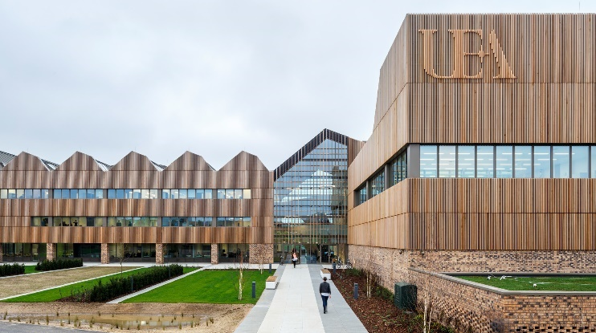

**Where does the teaching take place?**

It takes place at the Norfolk & Norwich Clinical Skills Resource Area, 1st Floor, Bob Champion Research & Education Building over the road from the main Norfolk and Norwich Hospital site.

**How long will the teaching take?**

**Depending on the subject being taught, teaching sessions can run from between one hour to a maximum of three hours.**

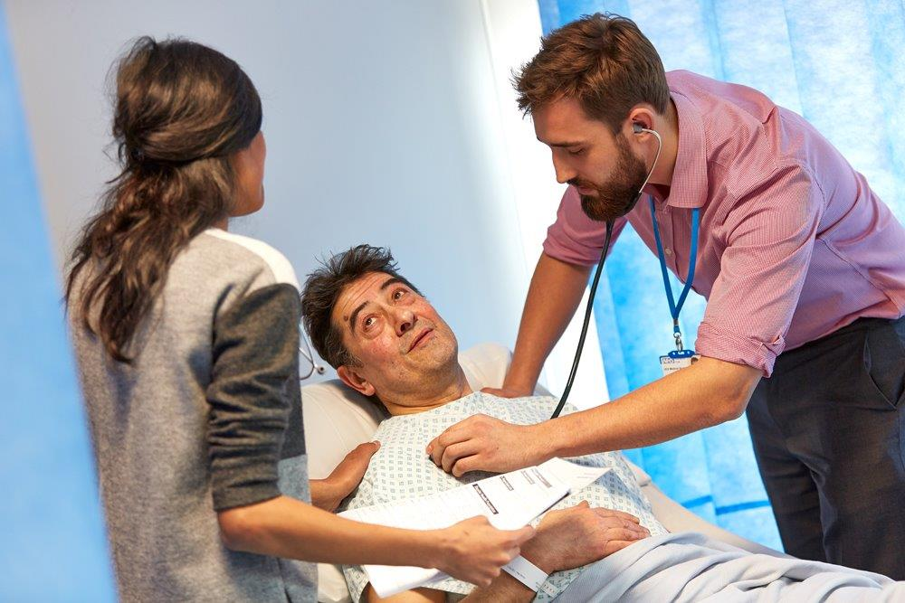

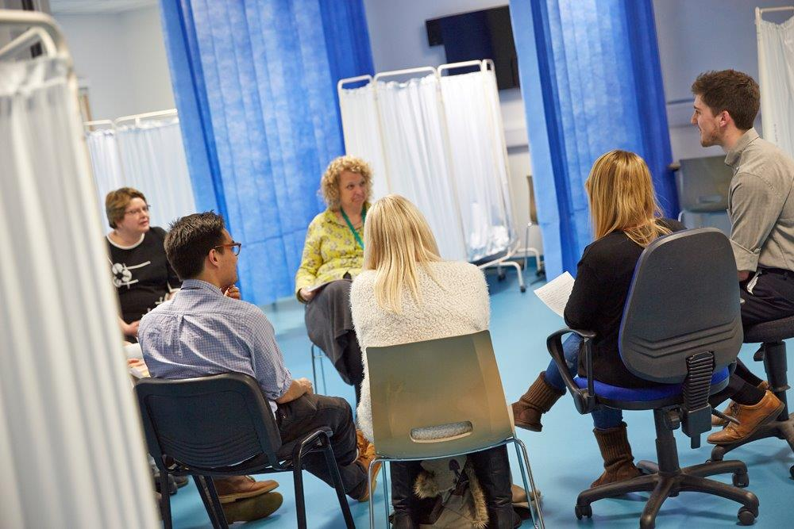



Could You

Help With

Medical School

Teaching?

**What does volunteering involve?**

Students training to be doctors learn best from patients.

Volunteer patients attend a session led by a doctor. They will be asked to talk to students, and they may also be examined by students.

It is likely that you will be asked to talk about your condition and how it affects you. The tutor may wish to demonstrate the best way to examine a patient and discuss your story.

We will tell you in advance what to expect and to check that you are happy to volunteer.

**Will I be given information on my own case?**

**The tutor may not be the healthcare professional you normally see in clinic. If you have any questions about your treatment, these should be saved for your next outpatient appointment.**

**The session is mainly for teaching students and doesn’t replace your clinical management.**

**Our volunteer patients do tell us they enjoy participating in sessions and potentially learning new information about the conditions that affect them.**

Patient volunteers have an early input to a medical students’ career, and they help shape tomorrow’s doctors.

If you can volunteer at the Medical School or would like more information, call 01603286618, email patient.teaching@nnuh.nhs.uk or speak to your consultant at your next appointment.

